Group 2: Evan Brisbin, Minh Quan Tran
CSCI 414 Platform-Based Development
Lab 02: TCP Sockets & Flow Control

Task 2:
- Handshake Trace: Record ISN, relative sequence numbers, and initial window advertisements for SYN and SYN-ACK.
We got the following fields for the first SYN packet:
- Sequence Number: 0 (relative sequence number)
- Sequence Number (raw): 992947609
- Window: 3
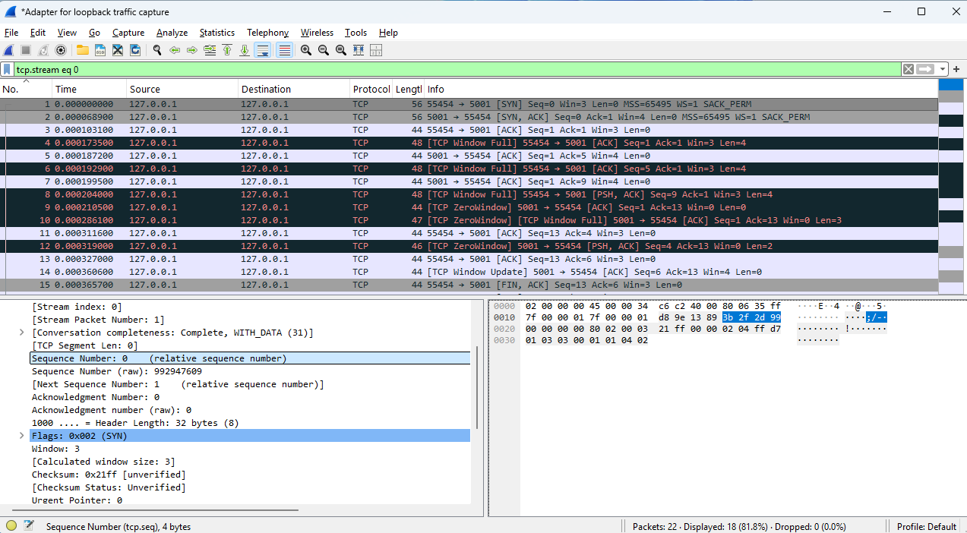
Also, we were able to obtain the following field for the first SYN-ACK packet:
- Sequence Number: 0 (relative sequence number)
- Sequence Number (raw): 2008480766
- Window: 4
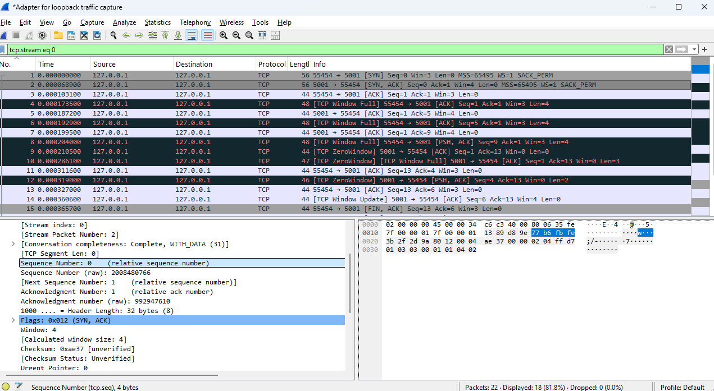

- Data Stream Math: Verify that receiver Ack matches sender Seq + Payload Length + (SYN/FIN cost).
Yes, we have the Alice-to-Bob FIN capture with Seq = 13 and Ack = 6. Ack = 6 represents the 5 bytes “Hello” reply from Bob, starting at sequence 1, so 1 + 5 = 6.
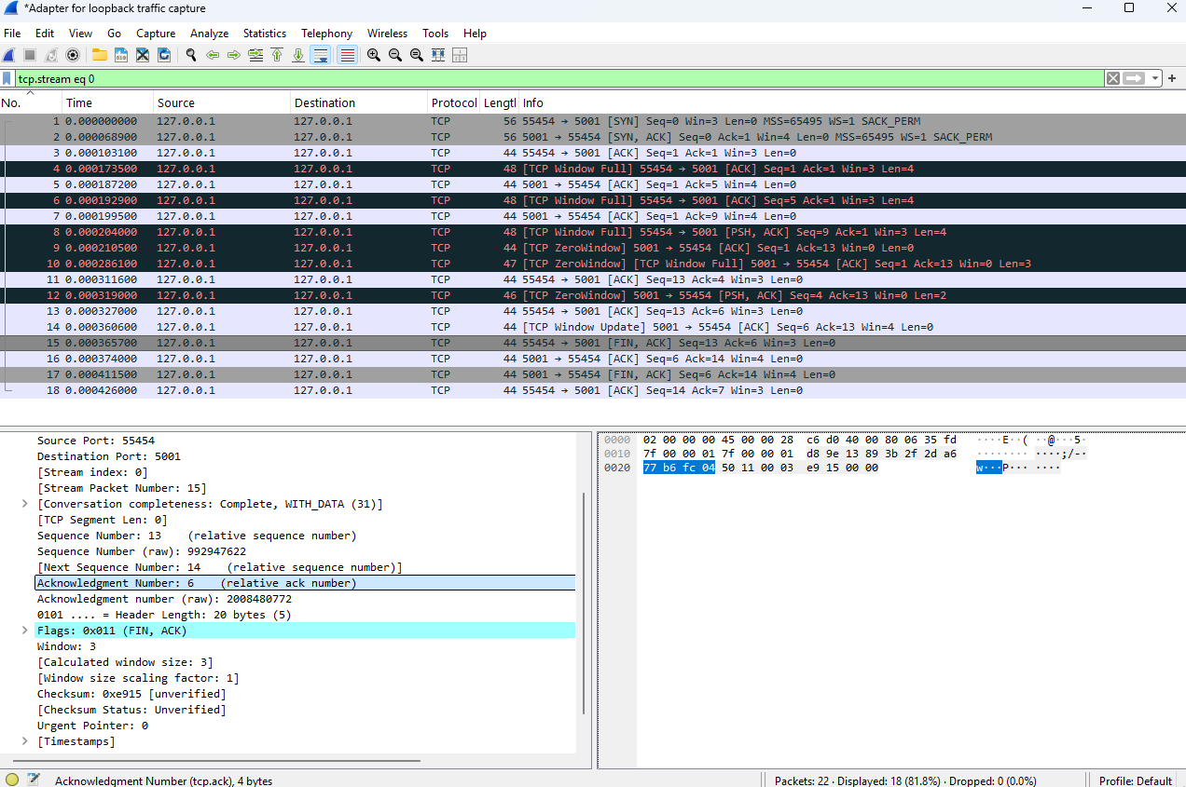
Also, when we examine the Bob-to-Alice FIN capture, we see Seq = 6 and Ack = 14. Ack = 14 in this case represents the consumption of sequence number 13, which is the 12-byte “Goodmorning” message from Alice starting from sequence 1.
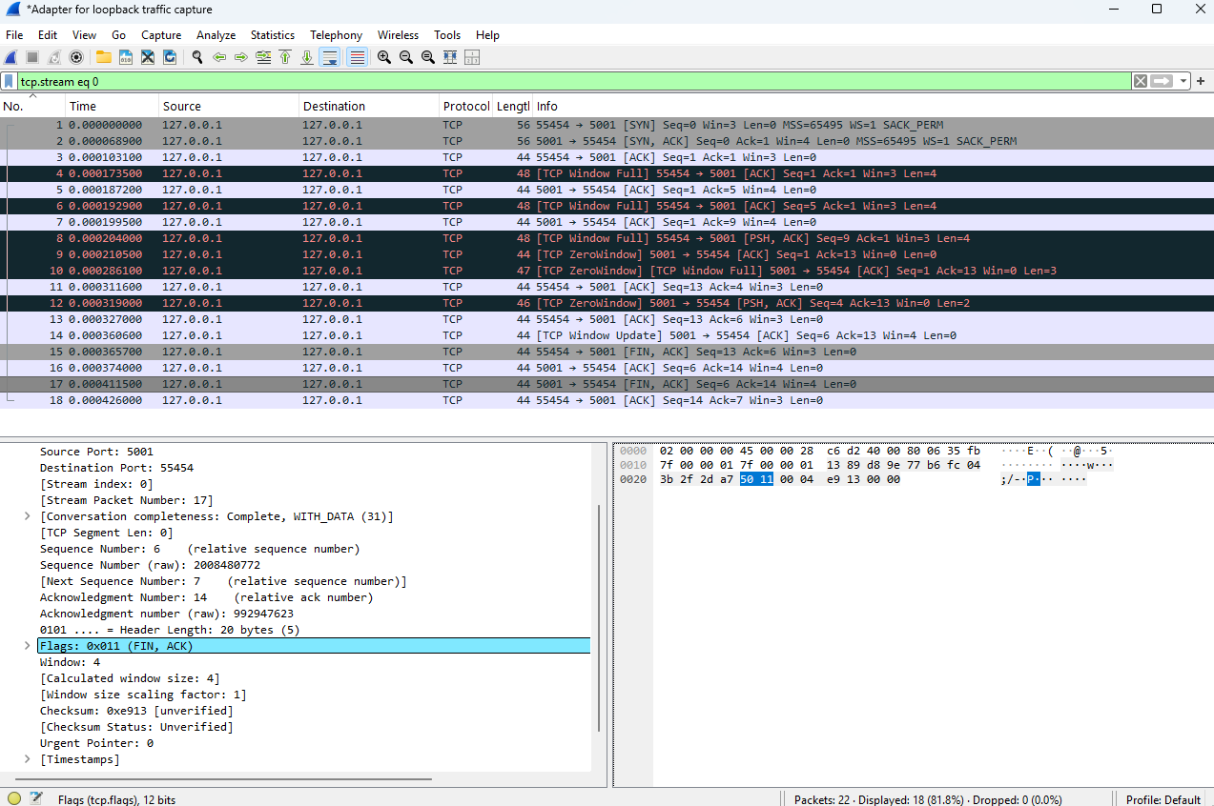

- Piggybacking Inspection: Confirm whether data was carried within ACK and FIN flag segments
When examining the packets, ACK was set, but since the TCP segment length is 0, the packet did not carry an application payload.
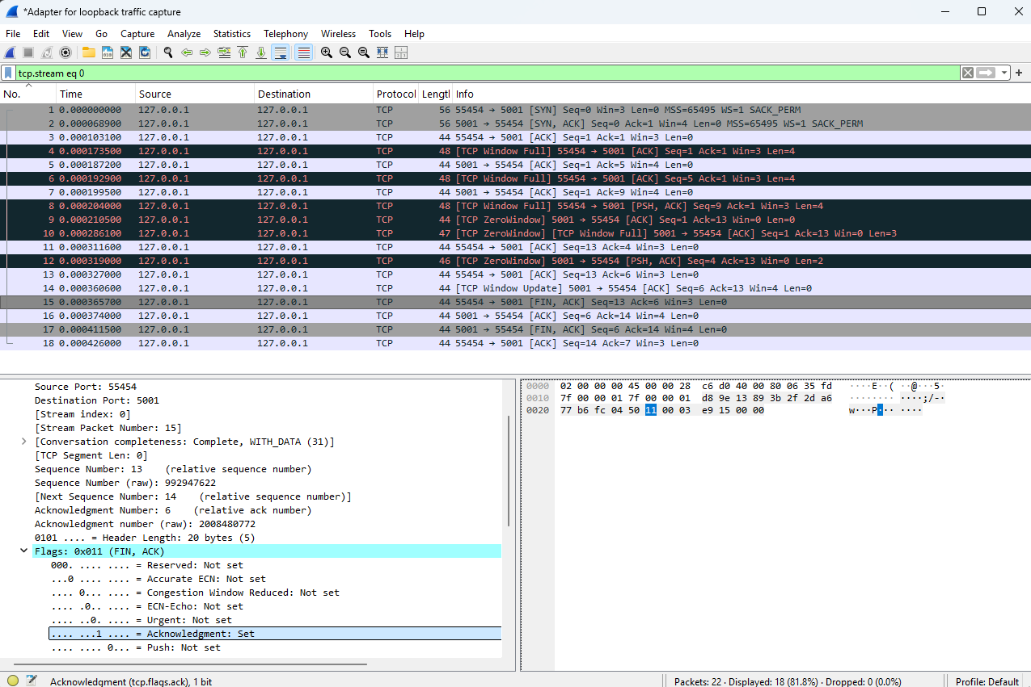
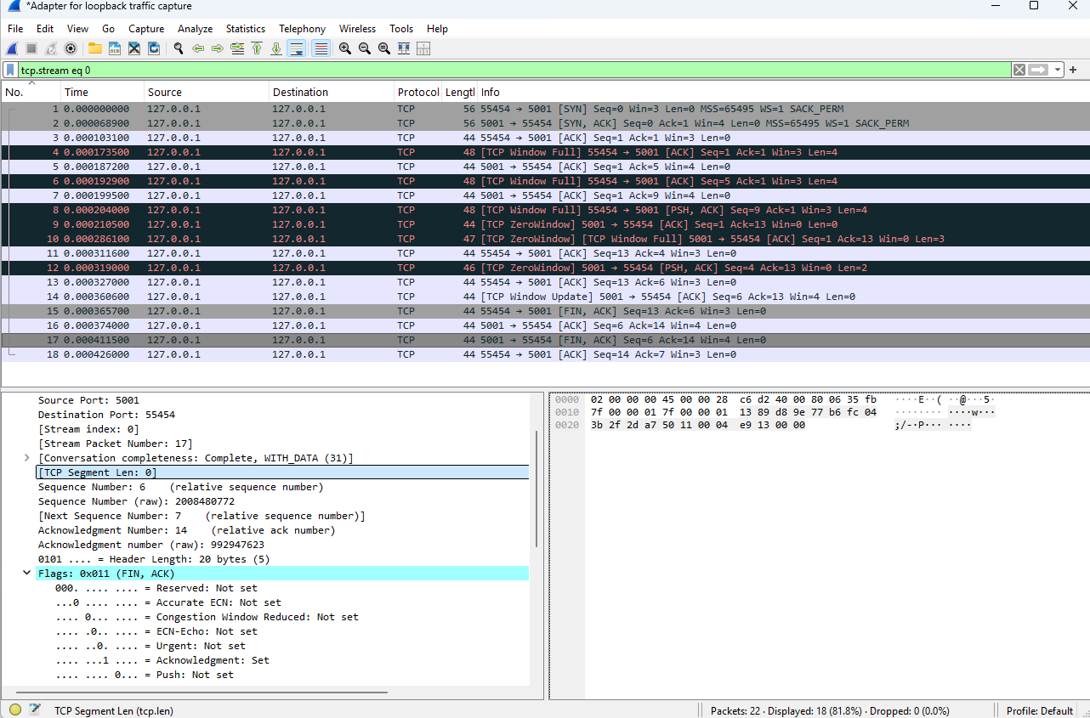

Task 3:
The limitations imposed by the receiver window ($$W_{rcv}=3 and W = 4$$) restricted the amount of unacknowledged data that Alice could transmit. As a result, the 12-byte payload had to be divided into a number of smaller batches for sending and sending the connectivity updates. Alice was not able to overlap the final data package containing the word “ning” (packet 8) with the indication of the connection close status, because the data transmission and the socket shutdown are handled as separate operations, and one happens before the other. In the process of running the python program, sendall() allows sending of the data being simultaneously sent, while socket.shutdown(socket.SHUT_WR) sends the FIN flag only after data sending has been accomplished.

